Subject: Fylde at the Ullapool Guitar Festival


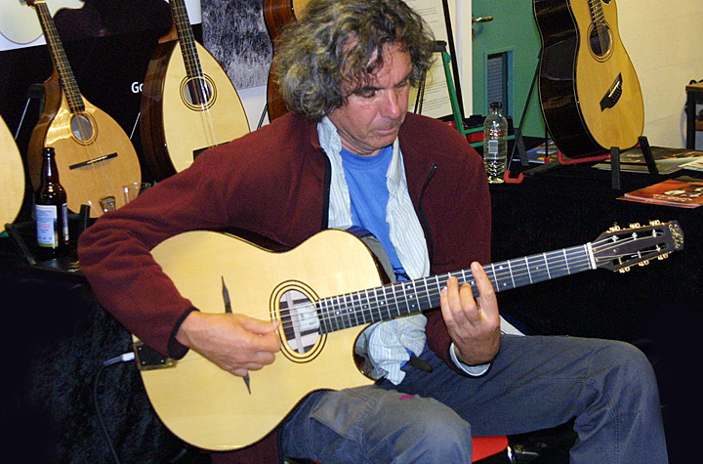
That’s it for another year; the Ullapool Guitar Festival is over. It was glorious weather this time, for a change, except for the wind that played chaos with Ken Nicol and Clive Carroll’s golf. Apparently the trick was to hit the ball out over Loch Broom, and watch it bend round back over dry land. I think the only reason they play golf is to blow the cobwebs away after the late sessions.
The popular comment at the end of the weekend was "please do exactly the same next year", it really was that good. It’s a very unusual event, all the artists and paying guests mix freely and share music, drink, gossip and generally have a great time. More or less 24 hours a day. On top of that, add seven hours driving each way and all the preparation involved, we haven’t recovered a week later.

This week, back at work, has been chaos and has produced lots of news that will have to wait until the next newsletter. In the meantime, Moira has a backlog of " strictly come / apprentice factor / murders” to catch up with while I tap away at my keyboard. (Main picture: John Etheridge playing Gary Potter's guitar.)

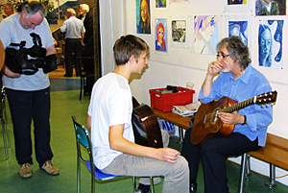  Gordon Giltrap  Here is Gordon Giltrap giving Ethan Thomas a one to one tutorial, just as the camera came round. All the concerts and a lot more were filmed, and will be available on a DVD in due course. Watch this space. It’s common to find little huddles of guests and artists at the makers’ stands and in various corners, and Gordon in particular was very generous with his time.  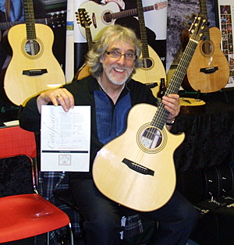  Gordon with the GG model that I donated to raise funds for the festival; it will be on eBay at some point. Happy bidding.  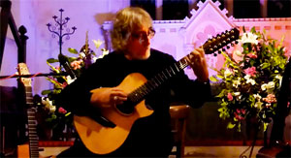  Here is Gordon with his 12 string that caused such a stir at the festival. I think the stage is on fire on this clip. VIDEO LINK  Jennifer Batten  Another guest at the stand was Jennifer Batten, playing that same Gary Potter guitar alongside Richard Smith playing the new Personal Selection Ariel, and Tristan playing the fool.  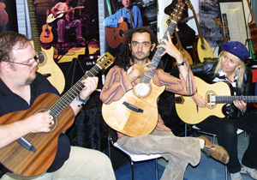  Jennifer sat through all the concerts, and the late night sessions, glued to whatever was going on at the time. Here she is making honey. VIDEO LINK  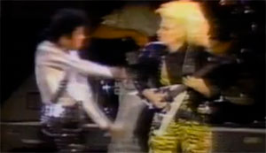  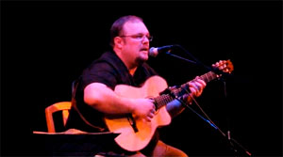  Richard Smith  Richard is a visitor from the US who plays mostly nylon strings, but was generous enough to say that it was a welcome change to find a steel string guitar that "didn’t fight him". This is Richard with some good advice for budding musicians. VIDEO LINK  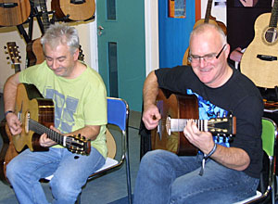  Tom Tom  Two very fine guitarists, Tom and Tom, collectively known as "Gypsy Swing" who describe their music as "Gypsy Punk". |  | 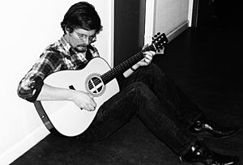  John Smith  John Smith trying to find a little peace to decide on his next purchase. Despite lots of persuasion, John is still determined to sell his 12 string. Do contact me if you are interested, it’s a beauty.  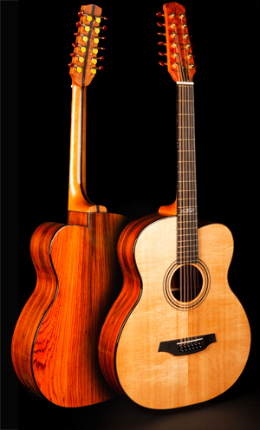  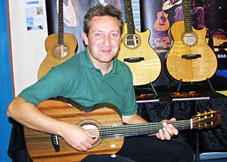  Clive Caroll  Clive Carroll (pictured) and Hugh Burns were both very tempted by the Personal Selection Ariel that will be featured in the next newsletter.  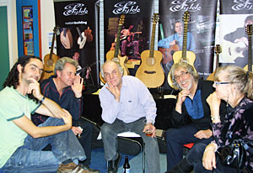  The finer points of Greek philosophy  Tristan, Ken, myself, Gordon and Hilary debating the finer points of Greek Philosophy.  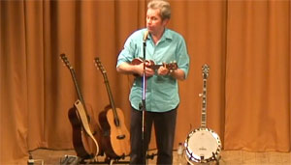  Ken Nicol  Ken Nicol was another Ullapool first timer. Both he and Gordon dazzled the audience with their playing, and gained lots of new fans. Ken smuggled his banjo into his set, and actually asked the audience if they wanted to hear it. They said yes, very strange, but then they also let him play his ukulele as an encore. Must be the drink. VIDEO LINK  John Etheridge  Here are John Etheridge, Gordon Giltrap, Tristan Seume and Ken Nicol, playing and singing, "Substitute" at the Fylde stand. I’m promised a video of this little gem. So again, look out for it sometime in the future. At one point, John looked up at my customer list, and said "There’s only one name not on that, and that’s me!!" Easily put right John. He did spend most of the weekend playing Gary Potters new Fylde, "the easiest acoustic I've ever played", so you never know.  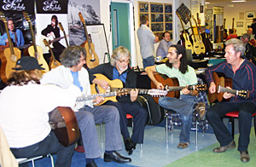
Best Wishes
Roger Bucknall
Fylde Guitars
www.fyldeguitars.com

